Language Policy

Language Philosophy:
All students at Lansdowne Elementary School will benefit from an appreciation for all languages. American Standard English is the primary language of instruction. It is the district and school policy that all students may be admitted to IB regardless of their mother tongue.
Development of language skills, both spoken and written, is critical to strengthening communication and is an expression of culture. We value the linguistic diversity of our school community and are dedicated to supporting first-language development, as well as the acquisition of an additional language. Multilingualism increases cognitive abilities, including problem-solving, creativity and memory, as well as a learner’s ability to communicate in diverse environments. Students acquire at least one additional language while in the IB program, while being encouraged to continue the study of their mother tongue as much as available or acquire a third language. Lansdowne Elementary offers a Multi-Language Learner (ML) program as well as instruction in Spanish, as a Connect Team class.
All teachers at Lansdowne are language teachers with responsibilities of facilitating communication in the school.
Support for students who are not proficient in the language of instruction.
Students who are not proficient in English will be supported by the ML teacher through pull-out small groups. Students are monitored by the ML program until they achieve a level of proficiency as indicated by an annual test they must take.

Learning of the host country or regional language and culture:
The ML program at Lansdowne is designed to help students not only learn the language but also the culture of the United States and the culture of our region.

Spanish Instruction: At Lansdowne Elementary, our second language is Spanish. The purpose is to introduce students to the Spanish language and the culture of the Spanish-speaking world. The instructional goal is for students to learn the basic principles of the language and to be able to speak with novice communication skills. Through exposure to the Spanish language, students also learn to acknowledge the distinctive characteristics of the Spanish-speaking culture and its impact on the world.
All students in kindergarten through fifth grade have Spanish once every rotation, on a six-day rotation. Our goal of teaching Spanish is to help students not only advance their Spanish communication skills, but also to develop an appreciation for the culture that comes with learning a language. We also help students to better understand the importance of learning an additional language with the hopes they will continue to be lifelong language learners.
School’s sociocultural circumstances:
Lansdowne IB World School is a public elementary school in Charlotte, NC with students in kindergarten through fifth grade. We work hard to support home languages while also instructing students in both English and Spanish. Our district, Charlotte Mecklenburg Schools, provides many resources for families who would like support in learning English or helping their children in their learning.
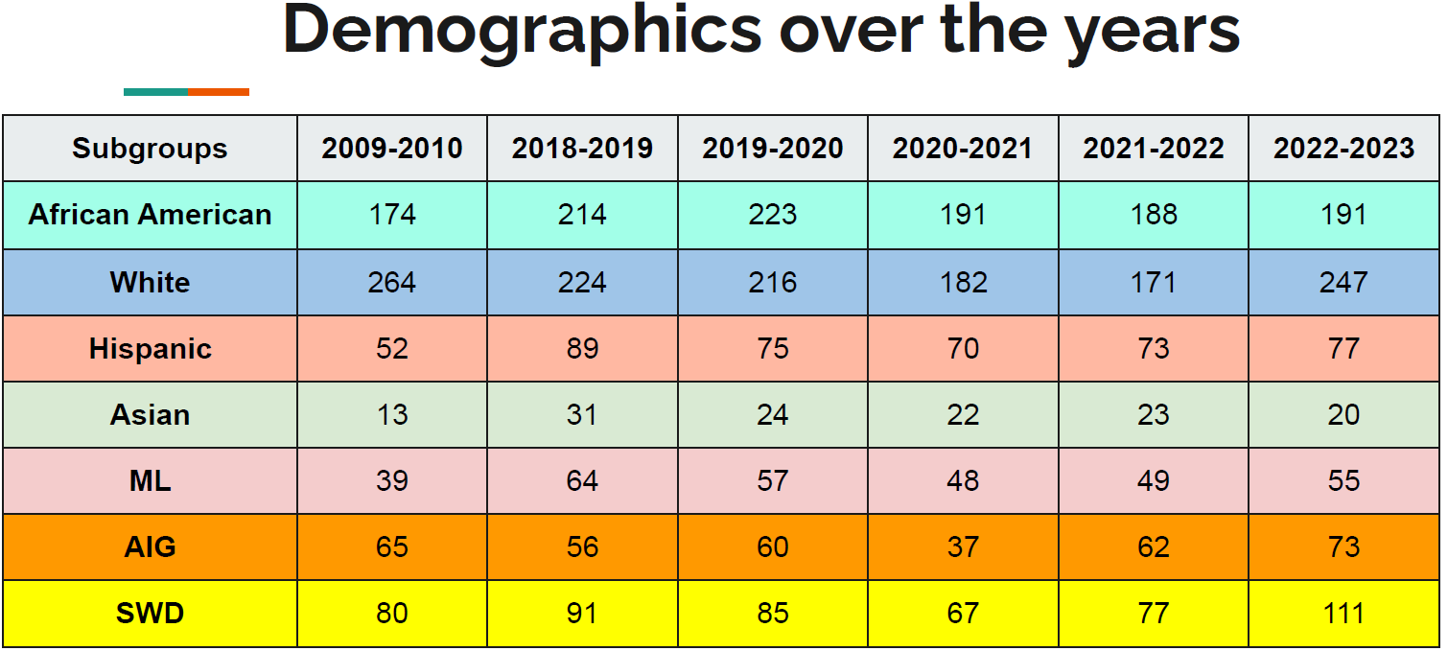
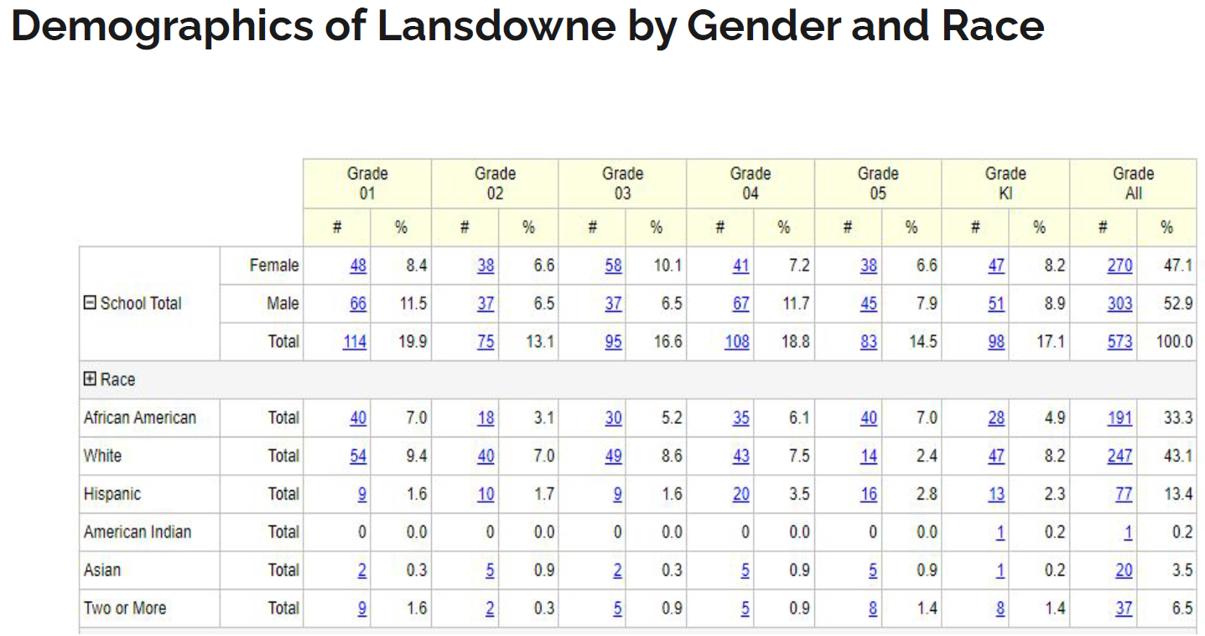
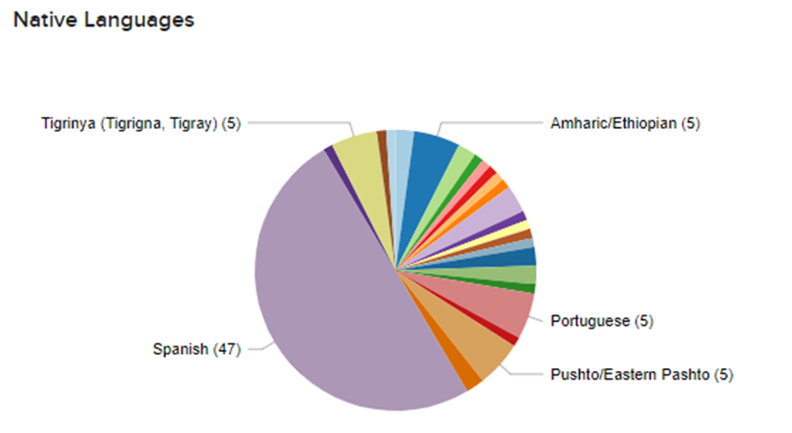

Language demographics
- Enrollment August 2022: 535 students
- Nationalities: African American, White Non-Hispanic, Hispanic, Asian
- Predominant populations: White Non-Hispanic (46.1%) and African American (35.7%)
- Multilingual Students (being served by ML): 10.1% (has grown in 2023-2024 year)
- Predominant languages: English, Spanish, Portuguese, Tigrinya, Amharic, and Pushto

District Links:
Charlotte Mecklenburg Schools – Learning and Language Acquisition
Charlotte Mecklenburg Schools – Learning and Language Acquisition Academic Assistance
Charlotte Mecklenburg Schools – International Center

